**Introdução ao Arduíno**

**Prática :**

**I – Objetivo**

## Demonstrar o uso do display de LCD de 16x2 utilizando a biblioteca LiquidCrystal.

**II – Introdução**

A biblioteca LiquidCrystal funciona com todos os monitores LCD compatíveis com o  Driver Hitachi HD44780. Há muitos deles no mercado, e você  poderá reconhece-los pela interface de 16 pinos.

Esta biblioteca permite que uma placa Arduino controle as telas LiquidCrystal (LCDs) baseadas no chipset Hitachi HD44780 (ou compatível), que é encontrado na maioria dos LCDs baseados em texto. A biblioteca trabalha no modo de 4 ou 8 bits (isto é, usando 4 ou 8 linhas de dados, além das linhas de controle rs, enable e, opcionalmente, rw).

**III – Montagem**

Antes de conectar o display de LCD à sua placa Arduino, sugerimos soldar uma tira de pinos no conector do display de LCD. Para conectar o display à placa, conecte os seguintes pinos:

|  |  |
| --- | --- |
| LCD | ARDUINO |
| RS | 12 |
| Enable | 11 |
| D4 | 5 |
| D5 | 4 |
| D6 | 3 |
| D7 | 2 |
| R/W | Terra |
| VSS | Terra |
| VCC | +5V |

Além disso, conecte um potenciômetro de 10kohm à tensão + 5V e GND, com seu terminal variável para o pino VO (pino3) do LCD. Um resistor de 220 ohms é usado para alimentar a luz de fundo da tela, geralmente nos pinos 15 e 16 do conector LCD

**O circuito**

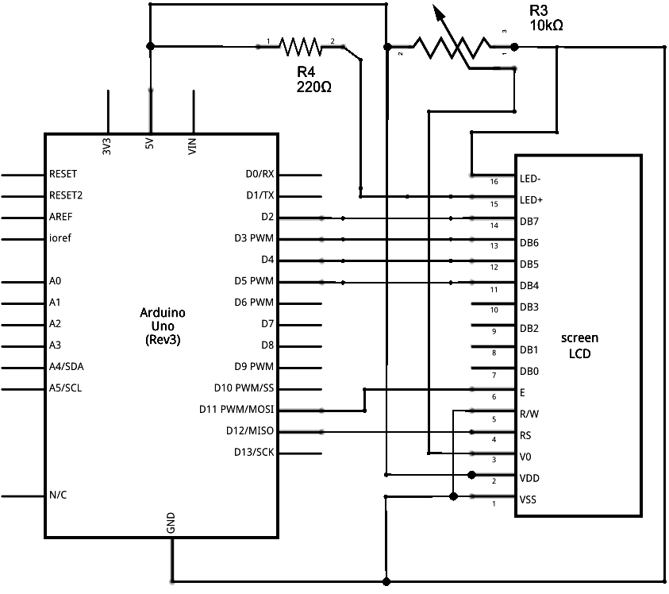

## A montagem

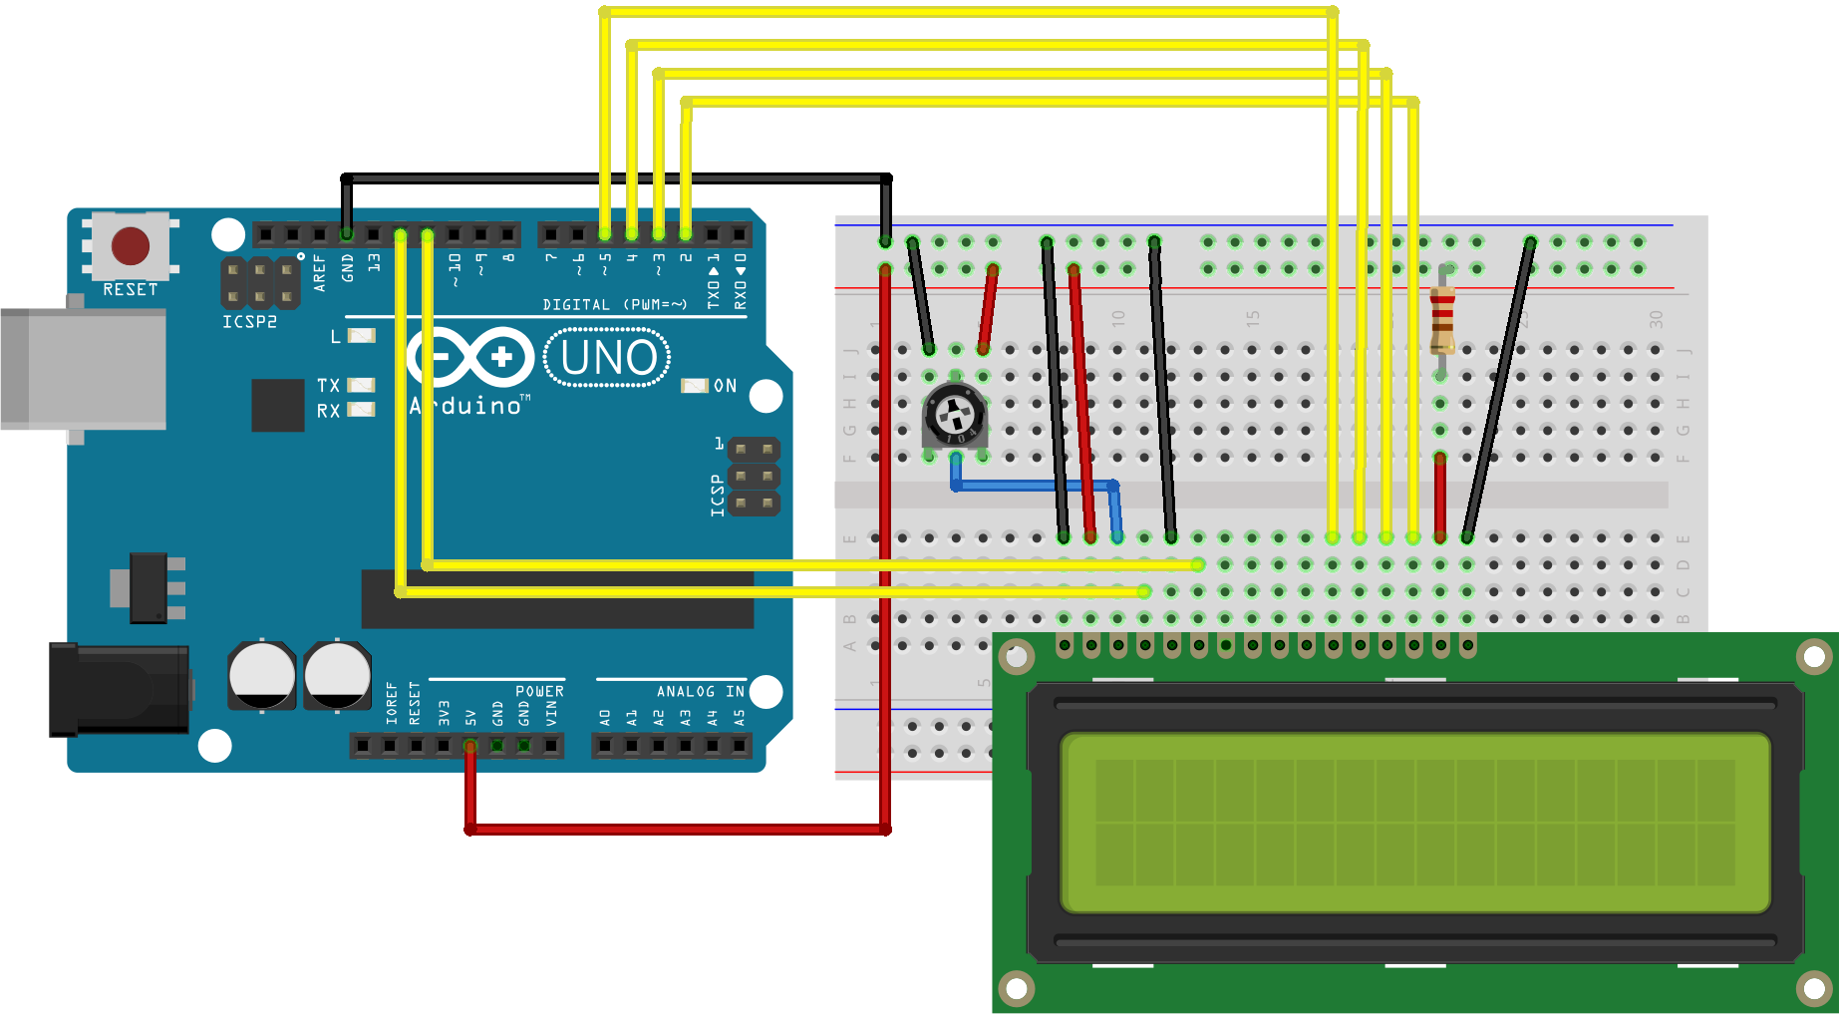

## O programa Arduino

/*  
  LiquidCrystal Library - Hello World  
  
 Demonstrates the use a 16x2 LCD display.  The LiquidCrystal  
 library works with all LCD displays that are compatible with the  
 Hitachi HD44780 driver. There are many of them out there, and you  
 can usually tell them by the 16-pin interface.  
  
 This sketch prints "Hello World!" to the LCD  
 and shows the time.  
  
  The circuit:  
 * LCD RS pin to digital pin 12  
 * LCD Enable pin to digital pin 11  
 * LCD D4 pin to digital pin 5  
 * LCD D5 pin to digital pin 4  
 * LCD D6 pin to digital pin 3  
 * LCD D7 pin to digital pin 2  
 * LCD R/W pin to ground  
 * LCD VSS pin to ground  
 * LCD VCC pin to 5V  
 * 10K resistor:  
 * ends to +5V and ground  
 * wiper to LCD VO pin (pin 3)  
  
 Library originally added 18 Apr 2008  
 by David A. Mellis  
 library modified 5 Jul 2009  
 by Limor Fried (http://www.ladyada.net)  
 example added 9 Jul 2009  
 by Tom Igoe  
 modified 22 Nov 2010  
 by Tom Igoe  
 modified 7 Nov 2016  
 by Arturo Guadalupi  
  
 This example code is in the public domain.  
  
 http://www.arduino.cc/en/Tutorial/LiquidCrystalHelloWorld  
  
*/  
  
// include the library code:  
#include <LiquidCrystal.h>  
  
// initialize the library by associating any needed LCD interface pin  
// with the arduino pin number it is connected to  
const int rs = 12, en = 11, d4 = 5, d5 = 4, d6 = 3, d7 = 2;  
LiquidCrystal lcd(rs, en, d4, d5, d6, d7);  
  
void setup() {  
  // set up the LCD's number of columns and rows:  
  lcd.begin(16, 2);  
  // Print a message to the LCD.  
  lcd.print("hello, world!");  
}  
  
void loop() {  
  // set the cursor to column 0, line 1  
  // (note: line 1 is the second row, since counting begins with 0):  
  lcd.setCursor(0, 1);  
  // print the number of seconds since reset:  
  lcd.print(millis() / 1000);  
}

=========================================================

/*  
  LiquidCrystal Library - Autoscroll  
  
 Demonstrates the use a 16x2 LCD display.  The LiquidCrystal  
 library works with all LCD displays that are compatible with the  
 Hitachi HD44780 driver. There are many of them out there, and you  
 can usually tell them by the 16-pin interface.  
  
 This sketch demonstrates the use of the autoscroll()  
 and noAutoscroll() functions to make new text scroll or not.  
  
 The circuit:  
 * LCD RS pin to digital pin 12  
 * LCD Enable pin to digital pin 11  
 * LCD D4 pin to digital pin 5  
 * LCD D5 pin to digital pin 4  
 * LCD D6 pin to digital pin 3  
 * LCD D7 pin to digital pin 2  
 * LCD R/W pin to ground  
 * 10K resistor:  
 * ends to +5V and ground  
 * wiper to LCD VO pin (pin 3)  
  
 Library originally added 18 Apr 2008  
 by David A. Mellis  
 library modified 5 Jul 2009  
 by Limor Fried (http://www.ladyada.net)  
 example added 9 Jul 2009  
 by Tom Igoe  
 modified 22 Nov 2010  
 by Tom Igoe  
 modified 7 Nov 2016  
 by Arturo Guadalupi  
  
 This example code is in the public domain.  
  
 http://www.arduino.cc/en/Tutorial/LiquidCrystalAutoscroll  
  
*/  
  
// include the library code:  
#include <LiquidCrystal.h>  
  
// initialize the library by associating any needed LCD interface pin  
// with the arduino pin number it is connected to  
const int rs = 12, en = 11, d4 = 5, d5 = 4, d6 = 3, d7 = 2;  
LiquidCrystal lcd(rs, en, d4, d5, d6, d7);  
  
void setup() {  
  // set up the LCD's number of columns and rows:  
  lcd.begin(16, 2);  
}  
  
void loop() {  
  // set the cursor to (0,0):  
  lcd.setCursor(0, 0);  
  // print from 0 to 9:  
  for (int thisChar = 0; thisChar < 10; thisChar++) {  
    lcd.print(thisChar);  
    delay(500);  
  }  
  
  // set the cursor to (16,1):  
  lcd.setCursor(16, 1);  
  // set the display to automatically scroll:  
  lcd.autoscroll();  
  // print from 0 to 9:  
  for (int thisChar = 0; thisChar < 10; thisChar++) {  
    lcd.print(thisChar);  
    delay(500);  
  }  
  // turn off automatic scrolling  
  lcd.noAutoscroll();  
  
  // clear screen for the next loop:  
  lcd.clear();  
}

/*  
  LiquidCrystal Library - Serial Input  
  
 Demonstrates the use a 16x2 LCD display.  The LiquidCrystal  
 library works with all LCD displays that are compatible with the  
 Hitachi HD44780 driver. There are many of them out there, and you  
 can usually tell them by the 16-pin interface.  
  
 This sketch displays text sent over the serial port  
 (e.g. from the Serial Monitor) on an attached LCD.  
  
 The circuit:  
 * LCD RS pin to digital pin 12  
 * LCD Enable pin to digital pin 11  
 * LCD D4 pin to digital pin 5  
 * LCD D5 pin to digital pin 4  
 * LCD D6 pin to digital pin 3  
 * LCD D7 pin to digital pin 2  
 * LCD R/W pin to ground  
 * 10K resistor:  
 * ends to +5V and ground  
 * wiper to LCD VO pin (pin 3)  
  
 Library originally added 18 Apr 2008  
 by David A. Mellis  
 library modified 5 Jul 2009  
 by Limor Fried (http://www.ladyada.net)  
 example added 9 Jul 2009  
 by Tom Igoe  
 modified 22 Nov 2010  
 by Tom Igoe  
 modified 7 Nov 2016  
 by Arturo Guadalupi  
  
 This example code is in the public domain.  
  
 http://www.arduino.cc/en/Tutorial/LiquidCrystalSerialDisplay  
  
*/  
  
// include the library code:  
#include <LiquidCrystal.h>  
  
// initialize the library by associating any needed LCD interface pin  
// with the arduino pin number it is connected to  
const int rs = 12, en = 11, d4 = 5, d5 = 4, d6 = 3, d7 = 2;  
LiquidCrystal lcd(rs, en, d4, d5, d6, d7);  
  
void setup() {  
  // set up the LCD's number of columns and rows:  
  lcd.begin(16, 2);  
  // initialize the serial communications:  
  Serial.begin(9600);  
}  
  
void loop() {  
  // when characters arrive over the serial port...  
  if (Serial.available()) {  
    // wait a bit for the entire message to arrive  
    delay(100);  
    // clear the screen  
    lcd.clear();  
    // read all the available characters  
    while (Serial.available() > 0) {  
      // display each character to the LCD  
      lcd.write(Serial.read());  
    }  
  }  
}

## IV - Bibliografia

https://www.arduino.cc/en/Reference/LiquidCrystal